Un Delphi automatizado para la búsqueda de consenso en la gestión de procesos universitarios
An automated Delphi for the search of consensus in the management of university processes

Miguel Cruz Ramírez
Yohan Díaz Ferrer
University of Holguín, Cuba.
University of Holguín, Cuba.
Emails
mcruzr@uho.edu.cu
ydferrer@uho.edu.cu

Received: 12/05/2019
Accepted: 10/12/2019

Resumen: La gestión de la calidad en los procesos universitarios demanda diversos elementos que requieren niveles de consenso. Constituye un problema la determinación consensuada de aspectos estratégicos tales como la misión, la visión, y los valores compartidos. En el trabajo se describe un procedimiento basado en la automatización del método Delphi, donde se combinan aspectos de la dirección por procesos, así como la experiencia en materia normativa y de planeación, existente en la Universidad de Holguín. Para el desarrollo del procedimiento se combinan técnicas prospectivas de consenso con métodos de la gestión estratégica de procesos, y con recursos de automatización.
Palabras clave: Método Delphi; Gestión universitaria; Gestión estratégica; Automatización; Expertos
Abstract: The management of quality in university processes demands several aspects that require a certain level of consensus. Consensual determination of strategic aspects such as mission, vision, and shared values is a problem. The paper describes a procedure based on the automation of the Delphi method, which combines aspects of management by processes, as well as the experience in normative and planning matters, existing at the University of Holguin. For the development of the procedure, prospective consensus techniques are combined with methods of strategic process management and automation resources.
Keywords: Delphi method; University management; Strategic management; Automation; Experts

Introduction
The search for consensus is an important aspect for the management of university processes, with an emphasis on quality and its sustainability. This means the collective construction of a shared culture. Therefore, a strategic look is required and, consequently, a collective consensus in the interest of continuous improvement. There are many spaces in higher education, where the search for consensus is recommended before making decisions. For example: define which processes are key for the university institution, within the framework of strategic planning; define shared vision and values; collectively construct the entity's visual identity; establish priorities, as in the case of research lines; set minimum indicators for the fulfillment of work objectives, defined within key result areas; propose prizes and recognitions, by commissions designated for this purpose; grant a certain position to a worker, especially if it requires highly qualified human capital; among others.
In general, the consensus refers not only to the agreement shared by the majority of the participants, but also to the mitigation of the objections that could occur between them (Fink, Kosecoff, Chassin, and Brook, 1984). There are several spaces that rely on the collective contest in person or not, where the search for consensus is a recurring need. A typical context consists of the conventional meeting, a space where a work agenda is followed under the scheme: checking agreements  analysis and discussion  adoption of new agreements. Sometimes the thread of a meeting may stray from the planned agenda, or a singular aspect may be oversized, a certain bias may occur, and even the most vehement opinion may prevail instead of the most reasonable.
Peiró and Portella (1993) point out that the need to make decisions in situations of uncertainty has led to a high use of consensus methods. These methods include the nominal group technique, the consensus conference, and the Delphi method. All three use successively and following highly formalized procedures, individual reflection techniques and stimulation of creativity, some type of structured discussion and the combination of individual judgments to achieve a global judgment of the group.
Delbeck, Van de Ven, and Gustafson (1984) explain that, in the nominal group technique, the participants meet physically. In this meeting and in a formalized manner, the ideas are presented, the points of view are individually established, the differences are made explicit and a direct vote is voted for each proposed solution. Likewise, Giraud and Jolly (1991) point out that consensus conferences consist of evaluating the available evidence, usually before reputable experts, accompanied by a conclusive report that is subsequently disclosed. On the other hand, the Delphi method has an origin closely linked to foresight, directed mainly towards decision-making, the evaluation of situations, and the forecasting of events. For years, the original features that typify this method in its classic form have been subject to adjustments and modifications, so that there are numerous types of Delphi in the literature (Cruz, 2009; Landeta, 1999).
The Delphi method has also been criticized because of its strong empiricism and insufficient theoretical foundation (Hasson and Keeney, 2011; Kauko and Palmroos, 2014), which requires research focused on its opportunities for improvement.
The effective use of the above resources requires a high degree of methodological rigor, especially in relation to the statement of objectives, the appropriate selection of participants, the definition of the degree according to which consensus is reached, the evaluation of the effect of the results, among others. In general, these resources have advantages and limitations, depending on the edge from which they are analyzed. This research focuses on the problem of reducing the deficiencies that limit the adoption of consensual decisions, specifically in the university context. To approach the solution of this problem, the previous resources can be useful.
Now, since the Delphi method is more forecast-oriented, in what follows this work will be based mainly on it, as a special case of a foresight method. In this sense, the objective is framed in the structuring of an automated procedure that optimizes the implementation of the Delphi method in the management of university processes at the University of Holguín (UHo).
The vision of the future is a key aspect for any planning process based on the collective consensus of higher education. Furthermore, considering the existence in each university of a human talent pool organized in scientific councils, expert groups, among other specialized groups, together with the increasing development of information and communication technologies, the implementation of the method is feasible. Delphi in an automated way, with an emphasis on continuous quality improvement.
Development
A diagnosis of the strategic management mechanisms by consensus in the UHo
The research starts from a diagnosis of strategic management agreed at the University of Holguín. For this, a survey is implemented to explore the perception of consensus in the framework of strategic decision-making of this university institution. As content to be explored, the importance of consensus for planning, the limitations for achieving it, the most appropriate spaces for implementation, as well as the individual construction of the concept of consensus are included. The survey is applied to 50 managers.
Regarding decision-making through consensus, respondents indicate that it is a way to achieve success based on commitment. The adoption of consensual decisions is relevant to involve the community in future development, for creative problem solving, and also for evaluating the rate of development. On the other hand, in relation to the types of decisions that require a unity of collective judgment, the observations revolve mainly around decisions of a strategic nature, those that affect the university community or that merit collective participation.
Managers argue that consensus should be sought within the framework of a participatory and democratic management style. They suggest that this is not always possible or particularly necessary, but that its exercise in decision-making for the future is important. As suitable spaces for the search for collective consensus, they identify the management councils, the advisory councils, group discussion workshops, the use of online resources, and the studies of states of opinion combined with cloisters and other scenarios that include the designation of groups for a shared projection of the future. Several respondents point out that a pleasant environment must be created in these spaces, proper planning and management must be carried out, and measures must also be taken to mitigate the negative effects of some individual opinions out of tune or out of place. Figure 1 shows a cause-effect diagram, containing the most recurring aspects pointed out by the respondents.
Three subsets are observed: contextual type, related to spatial / temporal location and technological assistance; of a personological type, centered on the subject that participates in the process of searching for consensus; and direction, focused on the subject responsible for the search for consensus. These causes, organized

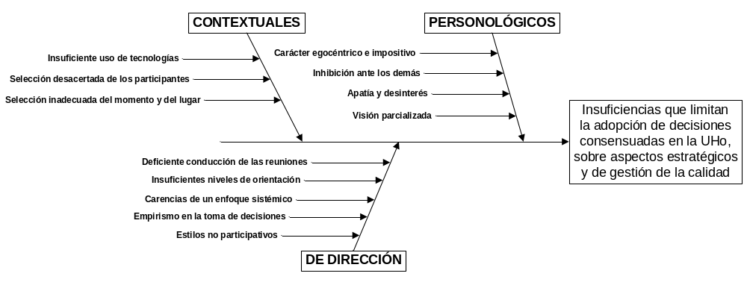
Figure 1: Limitations in strategic decision-making in the UHo
Source: self-made
The survey also invites comments on individual experiences related to the search for consensus. About half of managers did not respond in this section. The observed responses indicate recent imprints, related to the accreditation of careers and graduate programs, the strategic planning of the entity, the preparation of preliminary budget projects, the analysis spaces for the search for a corporate image, the work of commissions created to the selection of outstanding workers, among others. As can be seen, managers consider consensual decision-making important, identify the most suitable spaces for exercising this type of decision, point out the causes that affect its implementation, but experience difficulties or reservations when sharing their experiences in this regard. Therefore, it is necessary to face the problems of the present investigation by means of scientific methods.
The Delphi method as a special case of the expert judgment method
Expert judgment methods are predominantly empirical scientific methods, based on consulting people with extensive knowledge of the object of study. The synthesis, consensus, and stability of collective judgment can offer a plausible vision of the future, combining imagination, experience, and individual talent. Although it is possible to make fair use of an expert's individual views, there is assertive empirical evidence that collective judgment is superior, under certain conditions, to the trivial sum of the individual results of its members (Kaplan, Skogstad, & Girshick, 1950). In these methods, the information can be collectively contrasted. Furthermore, the number of factors considered by a group is never less than that which could be considered by a single person. Each expert will be able to contribute the idea they have on the subject under discussion, from their area of knowledge, experience and intelligence.
After analyzing the existing consensus models, in relation to the use of the expert method, Dong and Xu (2016) found that they follow a kind of general structure, made up of three procedures: first, the use of an aggregation function that incorporates preferences individual within a collective, second, the use of a measurement method for calculating the level of consensus among experts, and third, the use of a feedback mechanism to help experts modify their individual preferences and thus improve the level of consensus. The aggregation function can be symbolized as follows: F (I1, I2, ..., In) = C, where Ij (1  j  n) runs through the set of an individual preferences and C is the collective preference.
Among the best-known expert methods is Delphi, developed in the United States in the middle of the last century (Helmer, 1966). From its classic conception, there are four features that typify it: the presence of experts who answer questions under anonymity, the application of questionnaires or other regularly standardized instruments under an iterative process, the feedback controlled by a coordinating team, and the statistical group response.
These characteristics also satisfy the general structure described by Dong and Xu (2016), with the particularity that a panel of n experts is constituted who remain anonymous, the consensus measure requires mathematical rigor due to the need to provide a statistical response of group (Rowe and Wright, 1999), while the feedback process is similar to feedback from the fields of cybernetics and automation. Finally, instead of an aggregation function, there is a sequence of m aggregation functions, depending on the iteration step; that is: F = Fi (I1i, I2i, ..., Ini) = Ci (1  i  m), with the implementation of a certain stop condition.
Considering its objectives, the literature describes three types of Delphi: the classic, that of decision-making, and that of Delphi politics (Cruz and Rúa, 2018). The first reproduces the search for consensus in its most orthodox version; It regularly relies on a kind of forum to establish predictive facts about a specific issue or situation. The second promotes collaborative decision-making, while the third aims at generating ideas. Therefore, consensus ceases to be an end in itself and high value is placed on the systematization of retrospective observations by experts. Unlike the second variant, Delphi policy does not constitute a mechanism for decision-making, but rather a method for proposing options and alternatives, and also for establishing the pros and cons in controversial situations (Franklin and Hart, 2007).
An automated Delphi for finding consensus in process management
The main result of the present research focuses on an automated Delphi, designed to try to minimize the limitations listed above, and which adapts to the structural shape described by Dong and Xu (2016). Its application starts from the need to reduce the negative effects of subjectivity, where traditional methods may be inadequate. Having defined the place that corresponds to the Delphi method as an alternative thread for the management of university processes and, particularly, for the adoption of strategic decisions, it is convenient to establish the schematic representation of its elements. The way to be pursued is to combine two closely related approaches. On the one hand, as Ortiz (2014) points out, after identifying the general processes inherent in an organization and establishing the process map, there is a second stage related to documenting the processes. This author highlights the importance of establishing the specific maps, the cards, the display, the flowchart, and the scheduling of the process.
The second approach to consider is related to the automated nature of the application of the aforementioned method, closely related to the use of information and communication technologies. Therefore, technology is implemented in the form of a Work System, which constitutes a system where people and computers carry out a process in which they use information, technologies and other resources in order to produce products or services for a group of users. Its main components are users and beneficiaries, products or services, activities and processes, participating actors, as well as information and technologies (León, 2016). Accordingly, it is already possible to approach the documentation of the “automated Delphi” process as a Work System. Their description is synthesized in the scheme of Figure 2.

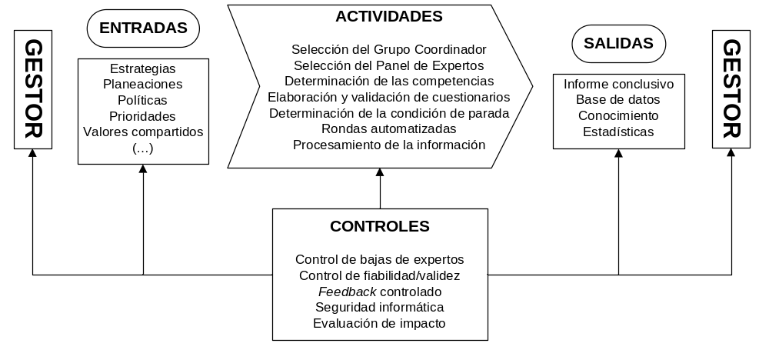
Figure 2: An automated Delphi for the management of university strategic processes
Source: self-made
As can be seen, in this alternative thread the input sources and the output receivers are coincident, that is, whoever demands the result is the same one who receives it. Therefore, this perspective constitutes a client-process-client type service, although this should not be understood absolutely, since there is the possibility that the information accumulated in the database management system may be useful for third parties. Regarding the establishment of a schedule, it should be noted that this depends on the objective set by the manager of applying the method. Therefore, in each case, it must be prepared by the coordinating group and approved by the corresponding instance. Both the deployment of the process and the schedule must correspond to the flowchart in Figure 3, where a procedure for the implementation of automated Delphi is represented, in the context of higher education and with an emphasis on continuous quality management with sustainability approach.
It is a sub-process structured by the following elemental components: preparation, development, conclusion, and impact. This is closely linked to the plan  do  verify  act cycle, since the impact evaluation closes the process and, at the same time, constitutes a new source of problem generation, which opens a new cycle. In turn, the above components are structurally and functionally defined by stages that take place in four fundamental scenarios, demarcated by the actions of various actors:

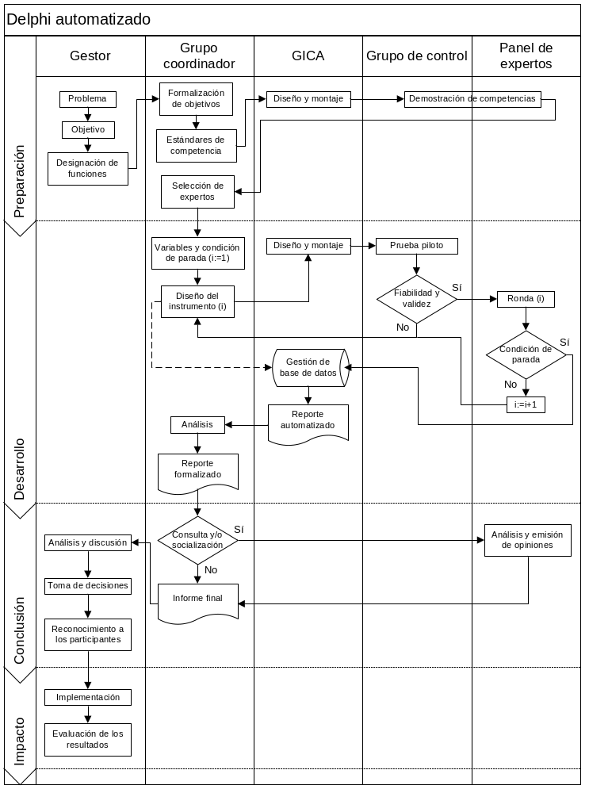
Figure 3: An automated Delphi for the management of university processes
Source: self-made
• A manager, who defines the objective and processes or designates the coordinating group and possible experts. This fulfills the double role of supplier / client and acts on a final stage of impact evaluation.
• A coordinating group, which is responsible for the selection of experts through instruments designed for this purpose, as well as the technical implementation of the Delphi method.
• A group of academic competitive intelligence (GICA), which has among its functions prospective studies of institutional development.
• A control group, made up of previously appointed expert candidates, but who do not meet the standards defined by the coordinating group. The evaluation of the candidates can be carried out using a variety of devices that the literature records, such as the coefficients of competence. Unselected candidates may participate in pilot studies to improve the reliability / validity of the instruments.
• A panel of experts, which constitutes the raison d'être of the process. It is a reservoir of experience and deep thought on the subject under study, where the synthesis of the collective vision is dialectically superior to the ideal sum of the individual criteria.
Some functional and structural considerations of automated Delphi
An element of essence is circumscribed in the sources and nature of the feedback. As can be seen, the central element resides in the cycle generated by the preparation and distribution of the instruments, the respective response, the stability analysis and the controlled feedback. Referring to the first stage of this cycle, Sackman (1974, p. 69, conclusions 1 and 7 of his epilogue) points out that questionnaires often have a “crude” design; and also, that when faced with ambiguous questions, “instantaneous” answers are generated. Without a doubt, the elaboration of the instruments is essential. Some authors recommend the use of complementary studies, so that the instruments can be perfected before reaching the panel.
Landeta (1999) offers very sound recommendations. For example, starting with an open question, but then closing more in each round; use clear and concise questions, taking care that they are not too many; grade each question (its length is inversely proportional to the degree of familiarity of the panel); emphasize evaluation, ranking, item comparison, and quantitative estimates; among other.
Feedback is extremely useful for raising the quality of the research result, providing valuable information and facilitating the achievement of more consensual opinions (convergence). Its sources are mainly three. The first of these is that the information provided by an individual can be transcendent enough, so that it is worth including in the next round. In short, the different idea will be submitted to collective analysis, judging its relevance in a general evaluative framework. Regarding the second source of feedback, the coordinators themselves can provide information in order to activate the debate, clarify certain concepts, mitigate biases, ask new questions, etc. It should be noted that the problem of biases is complex. For example, there is the pessimistic / optimistic bias where some individuals tend to be overly pessimistic in long-term estimates and, conversely, overly optimistic in short-term estimates. On the other hand, there is also dogmatic bias as a tendency to resist change.
The third source of feedback includes the information synthesized in the previous round, from the entire panel. Some authors call it "average opinion", expressible through the median and quartiles, or with the help of the average and standard deviation. In any case, it is preferable to use the term “regularities”, because although the questions asked must emphasize measurable variables, this measure does not hyperbolize the quantitative, in a multifactorial and basically qualitative reality. In general, little progress has been made in the qualitative processing of information generated after each round. The vast majority of the modifications leave the statistical group response immovable, since they emphasize quantitative synthesis (Cruz and Crespo, 2019).
Another important aspect that should not be overlooked is the stop condition, which is established and executed by the coordinating group during the development stage. In its usual form, this condition is usually reduced the moment consensus is reached. Experience has eloquently shown the lack of viability of an a priori convergence assumption. Several investigations have shown that the ideal of absolute consensus does not solve the problem of the stop condition (Landeta, 1999). In any case, some empirical studies indicate that, from a certain point, a stability of criteria is observed in the panel of experts (Cruz and Martínez, 2012), which does not imply a specific but plural consensus. In other words, probably when looking for a solution to a problem, one variant does not predominate, but two, three, etc. However, the implemented procedure must conceive a stop condition that imposes restrictions, so that the number of variants does not exceed a reasonable minimum amount.
This aspect involves a high preparation and experience of the coordinating group. It also implies taking into consideration the particularities of the problem submitted to the experts' analysis, as well as objective conditions related to decision-making, such as immediacy, transcendence, among others. For this reason, considering in the first instance the number of variables examined, the stopping criterion may consist of prefixing the number of rounds, using measures of central tendency such as the interquartile range, the variation of a certain indicator from one round to another, etc. (Landeta, 1999). Control of the stop condition is possible automatically, however this should not be fully understood.
During the instrument design stage, the coordinating group must systematically monitor the convergence or divergence of the process with respect to the pre-established stop condition. In this way, it is possible to take timely decisions that lead to a modification of the stop condition. This possibility of modification is expressed in the dashed lines within the flow diagram of Figure 3.
Conclusions
The problems addressed constitute just the beginning of a process of analysis and rethinking of the adoption of consensual decisions in the management process, especially on issues of a strategic nature for the UHo. Several conclusions can be drawn from this study, some related to the complexity of the topic and the approach to a scientific and technological solution, and others related to the feasibility and relevance of implementation. For example, the results of the diagnosis allow us to list a large set of decision-making spaces that require consensus at different levels in the UHo, especially in the current stage of integration. The cases that originate the limitations in the adoption of consensual decisions in the UHo can be subdivided into contextual, personological, and properly directed.
The positioning of this study has started from the UHo process map, where decision-making can be conceived from the level of strategic processes, specifically within strategic management. The selection of the Delphi method facilitates the implementation of an automated procedure, not only for the characteristics of this prospective method, but also for the specificities of the UHo, where the development of information and communication technologies is closely related with present and future development. Furthermore, the reconstruction of the theoretical-practical bases of the Delphi method has shown advantages and limitations, which have been taken into consideration during the conception of the proposed procedure. Special attention must be given to the selection of experts, to the condition of stopping the process, to the quality of the questionnaires, and to the synthesis of controlled feedback. Otherwise, serious validity problems may occur, excessive process dilation over time, or even the proposal of a futile solution.
The proposed procedure is not the solution to the problem, but a possible alternative that can be implemented in the institution. The results of the implementation of the procedure should not be tacitly accepted by the manager, especially when this figure is responsible for solving the problem and has decision-making power. The final decision is the exclusive competence of the university management body empowered to adopt it, or of a manager at the corresponding level. Therefore, it is necessary to have alternatives that can come from the application of the procedure (when the convergence is plural), or from this and another path that the manager determines. In essence, it is convenient to approach the procedure as an alternative variant and not as a definitive solution.
Bibliographic references
Cruz, M. (2009). El Método Delphi en las Investigaciones Educacionales. La Habana: Editorial Academia.
Cruz, M., & Crespo, T. P. (2019). Problemas epistémicos asociados al uso del método Delphi en las investigaciones educacionales. En: Colectivo de Autores (Eds.), Ciencia e Innovación Tecnológica (vol. IV, pp. 1074-1083). Universidad de Las Tunas: Editorial Académica Universitaria, http://edacunob.ult.edu.cu/xmlui/handle/123456789/97
Cruz, M., & Martínez, M. C. (2012). Perfeccionamiento de un instrumento para la selección de expertos en las investigaciones educativas. Revista Electrónica de Investigación Educativa, Vol. 14, No. 2. http://redie.uabc.mx/vol14no2/contenido-cruzmtnz2012.html
Cruz, M., & Rúa, J. A. (2018). Surgimiento y desarrollo del método Delphi: una perspectiva cienciométrica. Biblios, No. 71, pp. 90-107, http://dx.doi.org/10.5195/biblios.2018.470.
Delbeck, A. L., Van de Ven, A., & Gustafson, D. H. (1984). Técnicas Grupales para la Planeación. Trillas: México.
Dong, Y., & Xu, J. (2016). Consensus Building in Group Decision Making. Searching the Consensus Path with Minimum Adjustments. New York: Springer. http://dx.doi.org/10.1007/978-981-287-892-2
Fink, A., Kosecoff, J., Chassin, M., & Brook, R. H. (1984). Consensus method: Characteristics and guidelines for uses. American Journal of Public Health, Vol. 74, pp. 979-983. https://www.rand.org/content/dam/rand/pubs/notes/2007/N3367.pdf
Franklin, K. K., & Hart, J. K. (2007). Idea generation and exploration: benefits and limitations of the policy Delphi research method. Innovative Higher Education, Vol. 31, pp. 237-246. http://dx.doi.org/10.1007/s10755-006-9022-8
Giraud, A., & Jolly, D. (1991). Origenes et defnition des conférences de consensus. En: A. Giraud & D. Jolly (Eds.), Les Consensus en Médicine. Analyse et Bilan des Conférences de Consensus dans le Monde (pp. 11-20). Paris: Doin Editeurs et Assistance Publique - Hôpitaux de Paris.
Hasson, F., & Keeney, S. (2011). Enhancing rigour in the Delphi technique research. Technological Forecasting & Social Change, Vol. 78, No. 9, pp. 1695-1704. http://dx.doi.org/10.1016/j.techfore.2011.04.005
Helmer, O. (1966). The Use of the Delphi Technique in Problems of Educational Innovations. Rand Corporation Paper P-3499. http://www.rand.org/pubs/papers/2006/P3499.pdf
Kaplan, A., Skogstad, A. L., & Girshick, M. A. (1950). The prediction of social and technological events. Public Opinion Quarterly, Vol. 14, No. 1, pp. 93-110. http://dx.doi.org/10.1086/266153
Kauko, K., & Palmroos, P. (2014). The Delphi method in forecasting financial markets. An experimental study. International Journal of Forecasting, Vol. 30, pp. 313-327. http://dx.doi.org/10.1016/j.ijforecast.2013.09.007
Landeta, J. (1999). El Método Delphi: Una Técnica de Previsión para la Incertidumbre. Barcelona: Ariel.
León, N. I. (2016). Sistema Informativo para la Dirección de Ciencia y Técnica (DCT) en la Universidad de Holguín (UHo). Trabajo final del diplomado Programa Europeo para la Enseñanza de la Gestión. Universidad de Holguín.
Ortiz, A. (2014). Tecnología para la Gestión Integrada de los Procesos en Universidades. Aplicación en la Universidad de Holguín. Tesis doctoral. Universidad de Holguín.
Peiró, S., & Portella, E. (1993). No todo es acuerdo en el consenso. Limitaciones de los métodos de consenso en los servicios de salud. Gaceta Sanitaria, Vol. 7, pp. 294-300. http://dx.doi.org/10.1016/S0213-9111(93)71165-6
Rowe, G., & Wright, G. (1999). The Delphi technique as a forecasting tool: Issues and analysis. International Journal of Forecasting, Vol. 15, No. 4, pp. 353-375. http://dx.doi.org/10.1016/S0169-2070(99)00018-7
Sackman, H. (1974). Delphi Assessment: Expert opinion, Forecasting, and Group Process. Rand Corporation Paper, R-1283-PR, April, Santa Monica, California. http://www.rand.org/pubs/reports/2006/R1283.pdf

